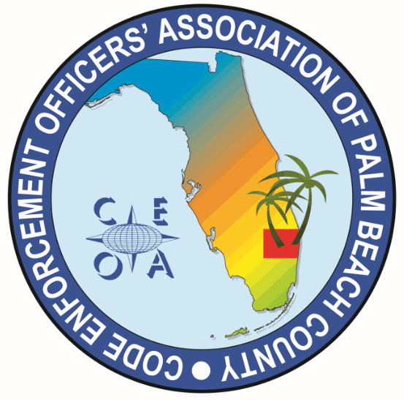
CODE ENNFORCEMENT OFFICERS ASSOCITION OF PALM BEACH COUNTY
MEETING AGENDA
FRIDAY, MARCH 22, 2026
VIA ZOOM

CALL MEETING TO ORDER, ROLL CALL, ESTABLISH A QOURUM

NEW BUSINESS

- CONSIDERATION OF UP TO A $300 CAMPAIGN CONTRIBTUTION FOR CHRIS AILES RUNNING FOR F.A.C.E SECRETARY AT UPCOMMING F.A.C.E CONFRENCE

ADJOURNMENT

